1. **What is software? What is software engineering?**

The programs and other operating information used by a computer is called software.

Software engineering is a process of developing a software product in a well-defined systematic approach.

―Software engineering is the art of developing quality software on time and within

budget.‖

Software Engineering is a systematic approach to the design, development, operation,

and maintenance of a software system.

1. **Explain types of software.**

A)Application software

* 1) Mobile app:
* - Application that run on mobile
* - Ex. Instagram, facebook, etc
* 2) Desktop app:
* - That run stand-alone in a desktop or laptop computer.
* - Ex. Microsoft office suite which includes Word, Excel and PowerPoint.
* - Ex. Outlook for email, and firefox, Google Chrome, Mozilla are the web browser.
* - Anti-virus is an application and so is the media player.
* 3) Web app:
* - That run on a web browser
* - ex. google.com, facebook.com, etc

B)System software

* provides the basic functions for computer usage and helps to run the computer hardware and system.
* is the s/w used by the computer to translate inputs from various sources into a language
* which a machine can understand.

C)Programming software

* This s/w is pawritten in a programming language.
* The purpose of programming is to create a program that exhibits a certain desired behavior.

1. **What is SDLC? Explain each phase of SDLC.**

SDLC is stand for Software Development Life Cycle.

1)Requirement: (customer)= SRS (software requirement specification),BRS, FRS, BRD, FRD etc.

2)Analysis: (architecture)=language, test plan, use case, flow chart/algorithm.

3)Design: UI/UX (Figma /photoshop)

4)Implementation: coder/developer

5)Testing: BUG

6)Development: release

7)Maintenance: corrective maintenance

Perfective maintenance

Adaptive maintenance

**4**. **What is DFD? Create a DFD diagram on Flipkart.**

A graphical or visual representation using a standardization set of symbols and notations to describe a business’s operations through data movement. A Data Flow Diagram (DFD) is a traditional way to visualize the information flows. It can be manual, automated, or a combination of both. It shows how information enters and leaves the system, what changes the information.

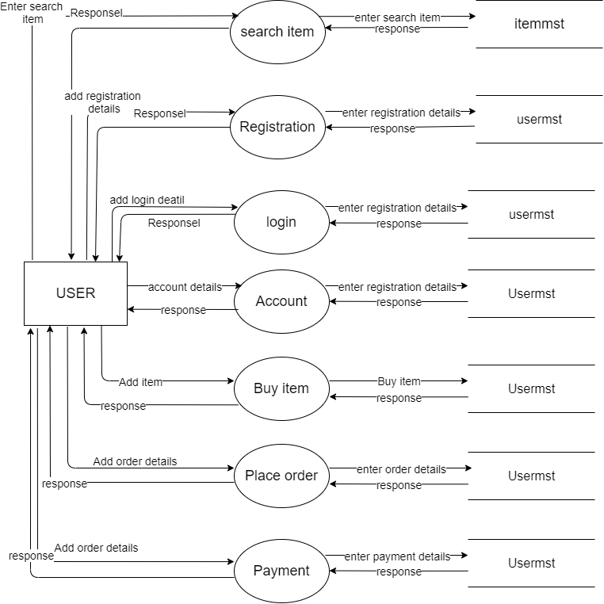

1. **What is flow chart? Create a flow chart to make addition of two numbers.**

-A diagram that shows the connection between different stages of a processor or parts of a system.

flowchart is a type of diagram that represents a workflow or process.

-A flowchart can also be defined as a diagrammatic representation of an algorithm, a step-by-step approach to solving a task.

-The flowchart shows the steps as boxes of various kinds, and their order by connecting the boxes with arrows.

-A flowchart is a graphical representation of the operations involved in a data processing system.

• Symbols are used to represent particular operations or data.

• Flow lines indicate the sequence of operations (Top to down sequence).

A flow chart is a graphical or symbolic representation of a process. Each step in the process is represented by a different symbol and contains a short description of the process step

. The flowchart symbols are linked together with arrows showing the process flow direction.

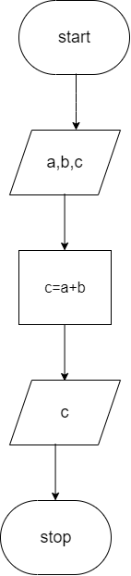

**6.What is use case diagram? Create a use case on bill payment on Paytm.**

use case diagram is a graphical depiction of a user's possible interactions with a system. A use case diagram shows various use cases and different types of users the system has and will often be accompanied by other types of diagrams as well. The use cases are represented by either circles or ellipses.

